1. Clone the Repository
First, clone the project repository to your local machine:
git clone https://github.com/Vennilavan12/Brain-Tasks-App.git
cd Brain-Tasks-App

2. Docker Container Setup

2.1 Create a Dockerfile
Create a file named Dockerfile in the project root with the following content:
Docker container
Create a Dockerfile
FROM nginx:alpine
RUN rm -rf /usr/share/nginx/html/*
COPY dist/ /usr/share/nginx/html/
EXPOSE 80
CMD ["nginx", "-g", "daemon off;"]

2.2 Build and Run the Docker Container
Build the Docker image and run the conatiner:
docker build -t brain-tasks-app .
docker run -d -p 3000:80 brain-tasks-app
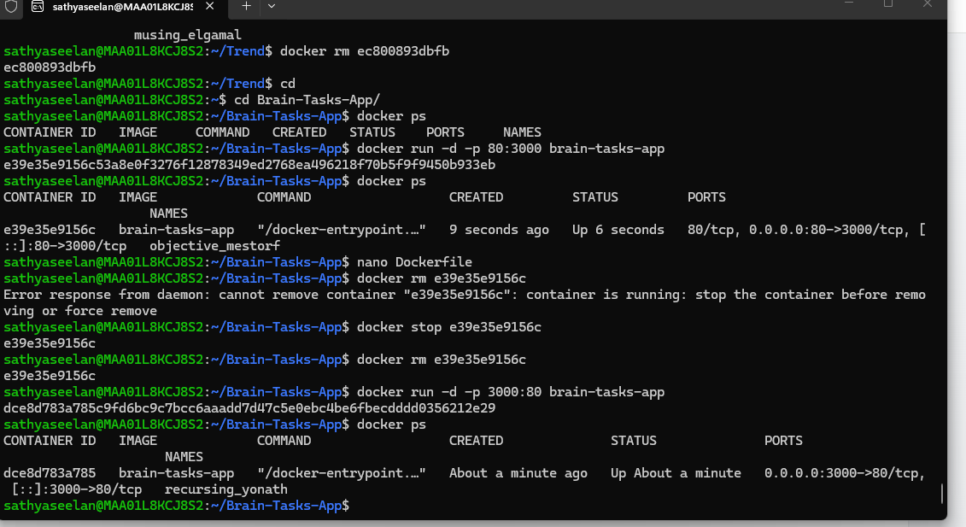
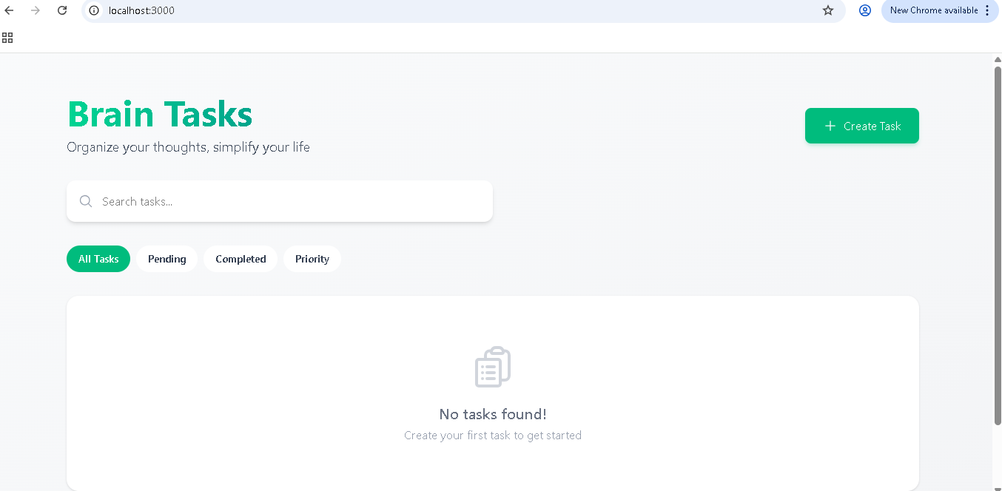

3. Push Docker Image to AWS ECR

3.1 Authenticate Docker to ECR
Run the following command to log in to your AWS Elastic Container Registry (ECR):
aws ecr get-login-password --region ap-south-1 | docker login --username AWS --password-stdin 517149106120.dkr.ecr.ap-south-1.amazonaws.com
docker build -t brain-tasks-app .
docker tag brain-tasks-app:latest 517149106120.dkr.ecr.ap-south-1.amazonaws.com/guviproject1:latest

docker push 517149106120.dkr.ecr.ap-south-1.amazonaws.com/guviproject1:latest

3.2 Verified
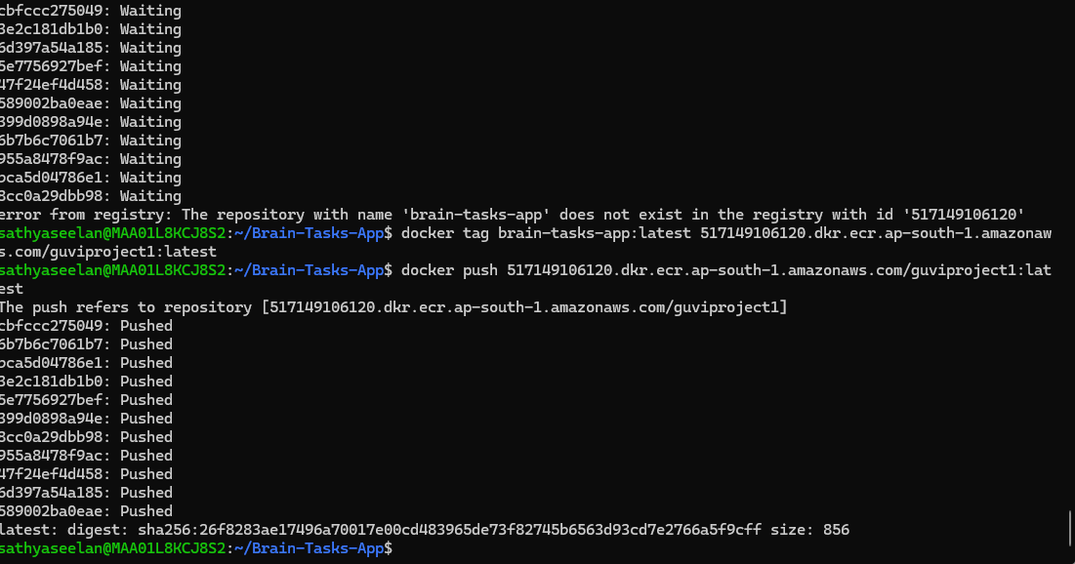
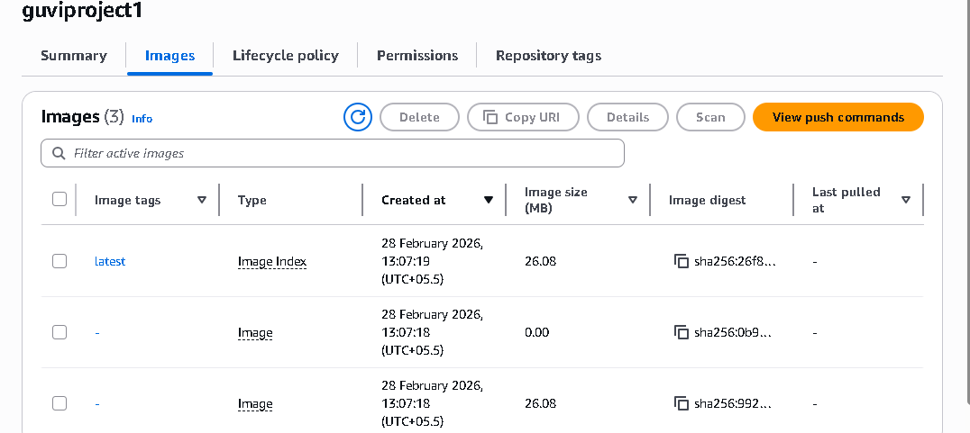

4. AWS EC2 Setup and Kubernetes Environment

4.1 Launch an EC2 Instance
- Log in to your AWS account.
- Launch an EC2 instance (e.g., Ubuntu 22.04 LTS).
- Connect to the instance

4.2 Install Docker
Update package lists and install Docker:
sudo apt update
sudo apt install docker.io -y
sudo usermod -aG docker ubuntu
sudo service docker start
sudo systemctl start docker
sudo systemctl enable docker

4.3 Install Kubectl
curl -LO https://dl.k8s.io/release/v1.29.0/bin/linux/amd64/kubectl
chmod +x kubectl
sudo mv kubectl /usr/local/bin/
kubectl version --client

4.4 Install Minikube
Download and install Minikube:
curl -LO https://github.com/kubernetes/minikube/releases/latest/download/minikube-linux-amd64
sudo install minikube-linux-amd64 /usr/local/bin/minikube && rm minikube-linux-amd64
sudo usermod -aG docker $USER && newgrp docker
minikube start --driver=docker --memory=1800 --cpus=2
kubectl get nodes

5. Kubernetes Deployment on Minikube / AWS ECR Image

5.1 Create Deployment

Deployment.yaml
apiVersion: apps/v1
kind: Deployment
metadata:
name: brain-tasks-deployment
spec:
replicas: 2
selector:
matchLabels:
app: brain-tasks
template:
metadata:
labels:
app: brain-tasks
spec:
containers:
- name: brain-tasks-container
image: 517149106120.dkr.ecr.ap-south-1.amazonaws.com/guviproject1:latest
ports:
- containerPort: 80

5.2 Create Service
Create a file named service.yaml:
apiVersion: v1
kind: Service
metadata:
name: brain-tasks-service
spec:
type: NodePort
selector:
app: brain-tasks
ports:
- port: 80
targetPort: 80
nodePort: 30007

5.3 Install AWS CLI
Update packages and install dependencies:
sudo apt update
sudo apt install unzip curl -y

curl "https://awscli.amazonaws.com/awscli-exe-linux-x86_64.zip" -o "awscliv2.zip"

unzip awscliv2.zip

sudo ./aws/install
AWS configure
aws configure

aws ecr get-login-password --region ap-south-1 | \
kubectl create secret docker-registry ecr-secret \
--docker-server=517149106120.dkr.ecr.ap-south-1.amazonaws.com \
--docker-username=AWS \
--docker-password=$(aws ecr get-login-password --region ap-south-1)
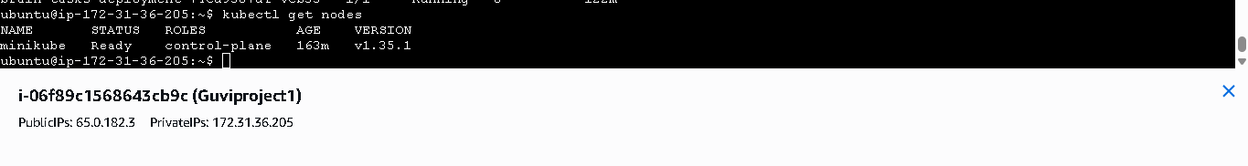

5.4 Access the Application
Forward the service port to your local machine:

kubectl port-forward --address 0.0.0.0 svc/brain-tasks-service 3000:80
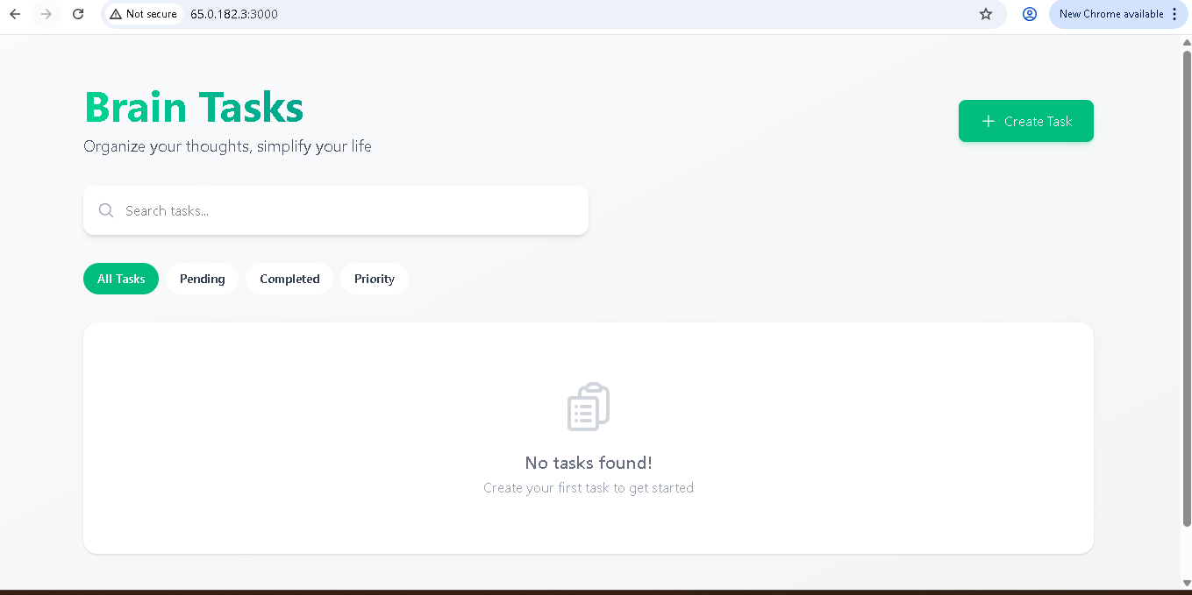

6. CI/CD with GitHub Actions (Build & Push to AWS ECR)

6.1 Workflow Overview
Instead of using AWS CodeBuild, we are using GitHub Actions (free for public repositories) to automatically build and push the Docker image to AWS ECR whenever code is pushed to the main branch.

6.2 Create GitHub Actions Workflow
Create a workflow file at .github/workflows/build-and-push.yml with the following content:
mkdir -p .github/workflows/ecr-build.yml
nano .github/workflows/ecr-build.yml
name: Build and Push to ECR

on:
push:
branches:
- main

jobs:
build:
runs-on: ubuntu-latest

steps:
- name: Checkout
uses: actions/checkout@v3

- name: Configure AWS credentials
uses: aws-actions/configure-aws-credentials@v2
with:
aws-access-key-id: ${{ secrets.AWS_ACCESS_KEY }}
aws-secret-access-key: ${{ secrets.AWS_SECRET_KEY }}
aws-region: ap-south-1

- name: Login to ECR
run: |
aws ecr get-login-password --region ap-south-1 | \
docker login --username AWS \
--password-stdin 517149106120.dkr.ecr.ap-south-1.amazonaws.com

- name: Build Docker image
run: |
docker build -t brain-tasks-app .
docker tag brain-tasks-app:latest \
517149106120.dkr.ecr.ap-south-1.amazonaws.com/guviproject1:latest

- name: Push Docker image
run: |
docker push 517149106120.dkr.ecr.ap-south-1.amazonaws.com/guviproject1:latest
ADD my AWS ID and AWS key in my repo secrets action.
AWS_ACCESS_KEY
AWS_SECRET_KEY
Add IAM Role -Add indentify provider
Give my repo details and give S3 access. Edit my turst policy
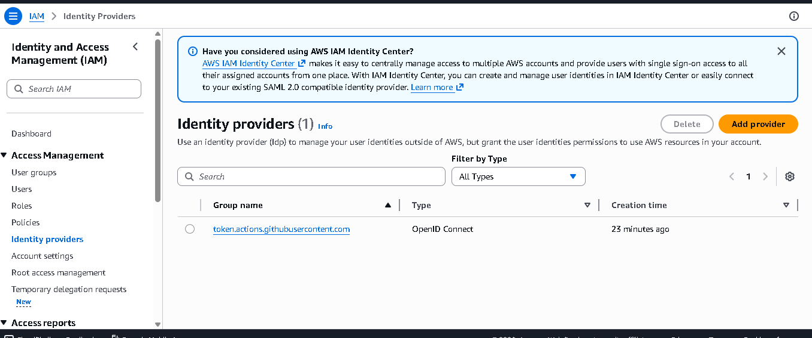

6.3 Push EC2 and Local Project Files to GitHub
Push your project, including EC2-related files or Kubernetes manifests, to GitHub
git init
git add .
git commit -m "Build pipeline"
git branch -M main
git remote set-url origin https://github.com/Sathyaseelan95/Brain-task-app.git
git push -u origin main

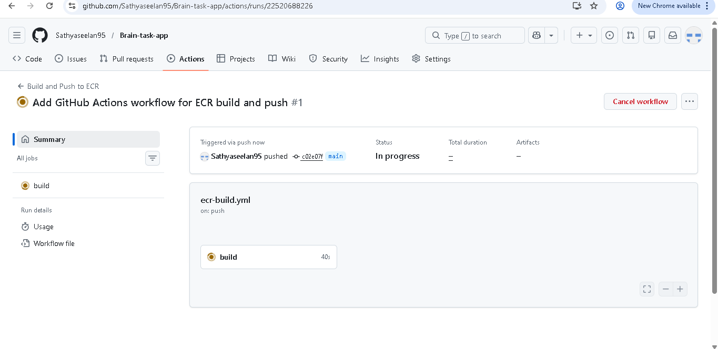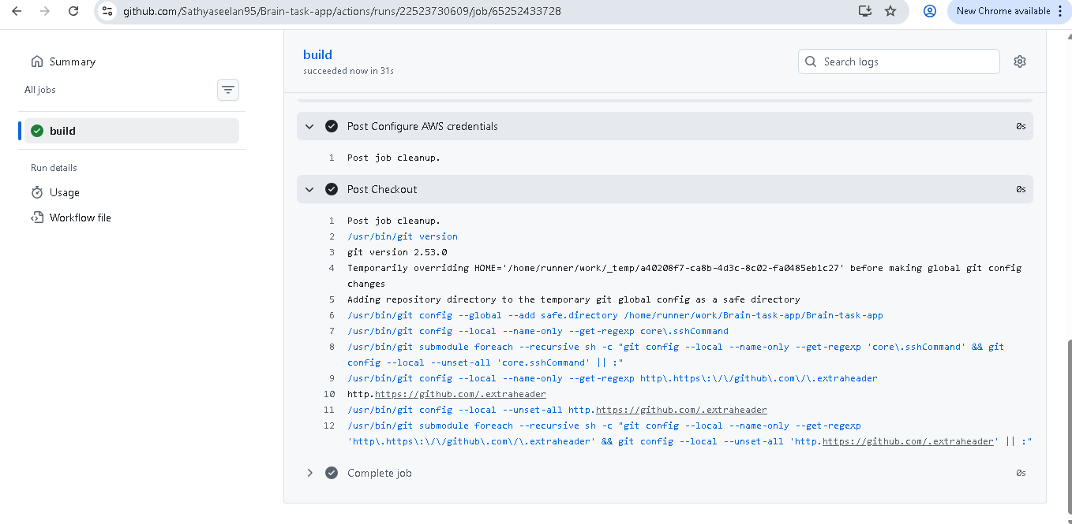

6.4 Redeploy Kubernetes Deployment
After the image is pushed to ECR via GitHub Actions, trigger a rollout restart on the deployment to use the new image:
checked


7. Monitoring Deployment Without CloudWatch
Since GitHub Actions is used instead of AWS CodeBuild, CloudWatch logs are not available. Instead, you can monitor your Kubernetes cluster and application logs directly.

7.1 Check Deployment Health
Check the status of deployments and pods:
kubectl get deployments
kubectl get pods
kubectl describe pod brain-tasks-deployment-74cd9587df-sphr2
kubectl logs -f brain-tasks-deployment-74cd9587df-sphr2